Named routes
Workshop #03
Flutter Developer Bootcamp

Purpose
This workshop demonstrates how to navigate screens with named routes.

Problem
In the provided workshop, you want to create a settings button. When the user clicks on the button, it will navigate to the settings screen using named routes. The button must be blue, and the settings screen must include a "go back" button to return to the home screen. The app bar of the settings screen must be blue, and the "go back" button should also be blue.

How to Solve
1. Checkout the workshop from Git Repo:
git clone -b <user-branch> <repo-URL>
2. Open the root folder inside VS Code
3. To build the app click the run option in the main method { }
4. Create a settings button on the home screen and navigate to the settings screen using named routes.

You Will Achieve

At the completion of the workshop, you'll learn how to use named routes to navigate between screens.

Screenshots

Before implementation (without Settings screen)
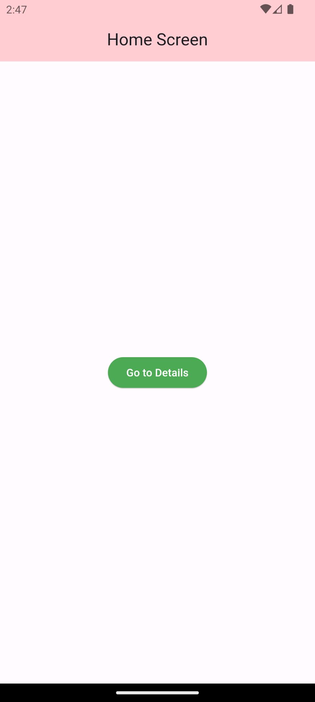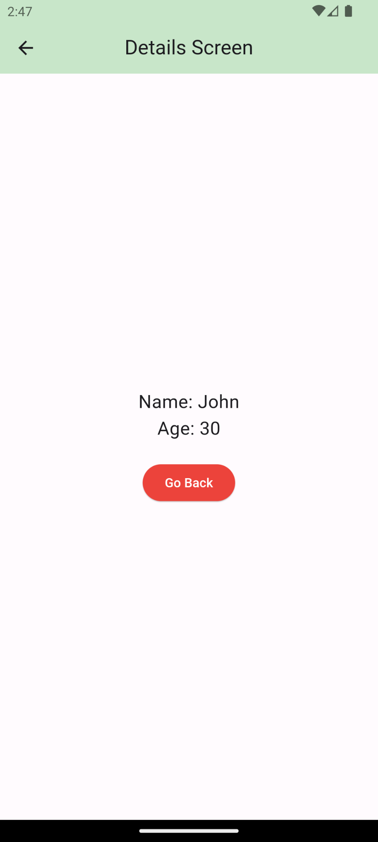

After implementation (With Settings screen)
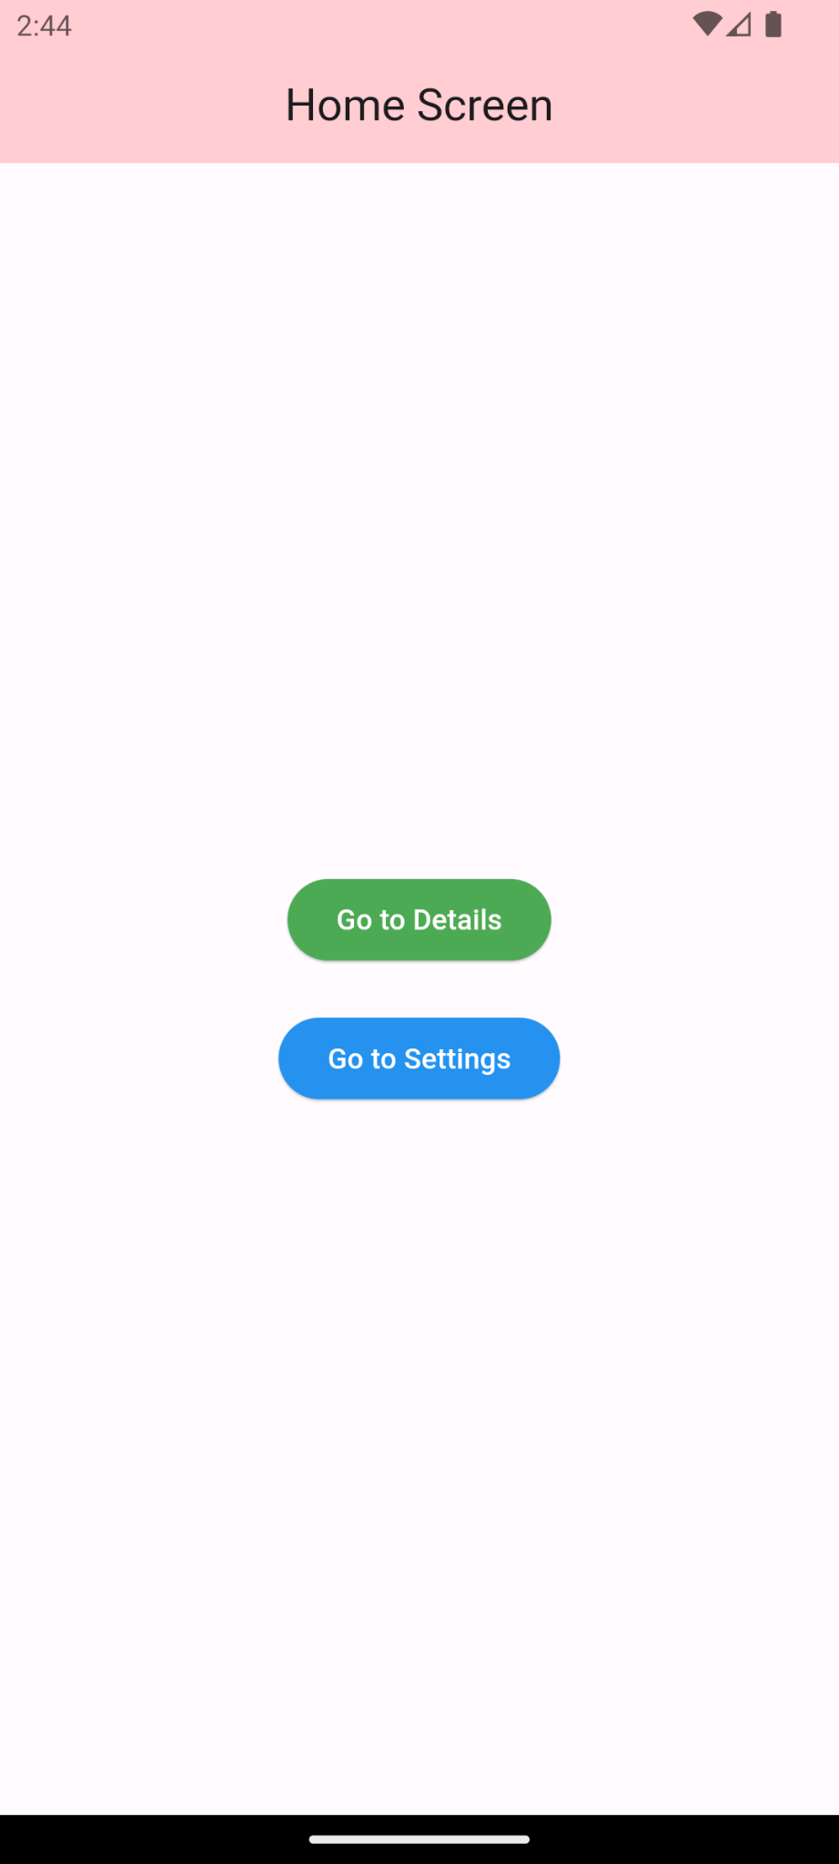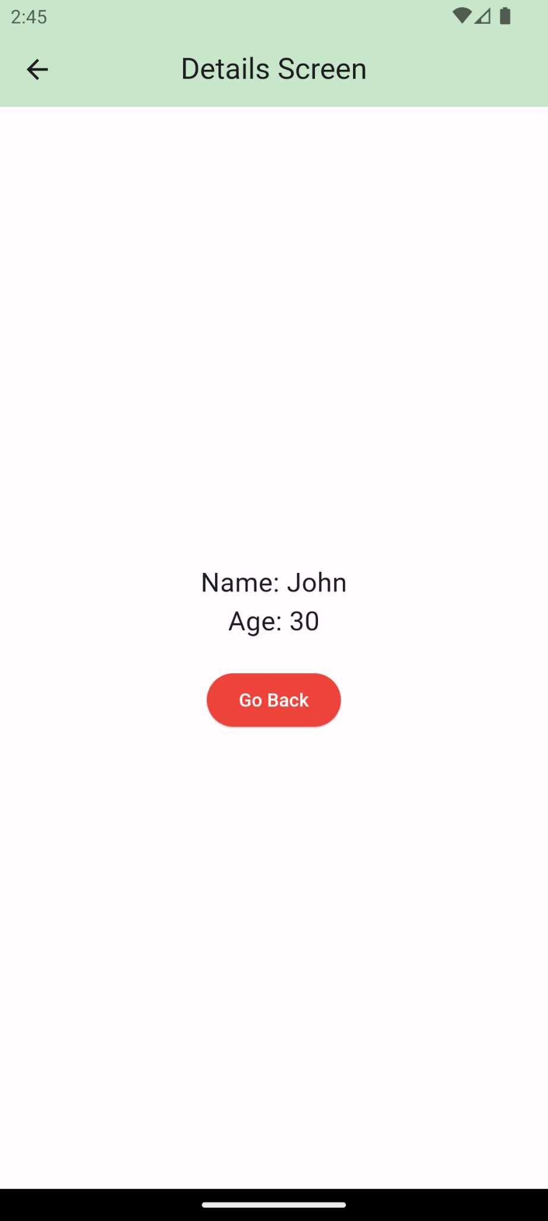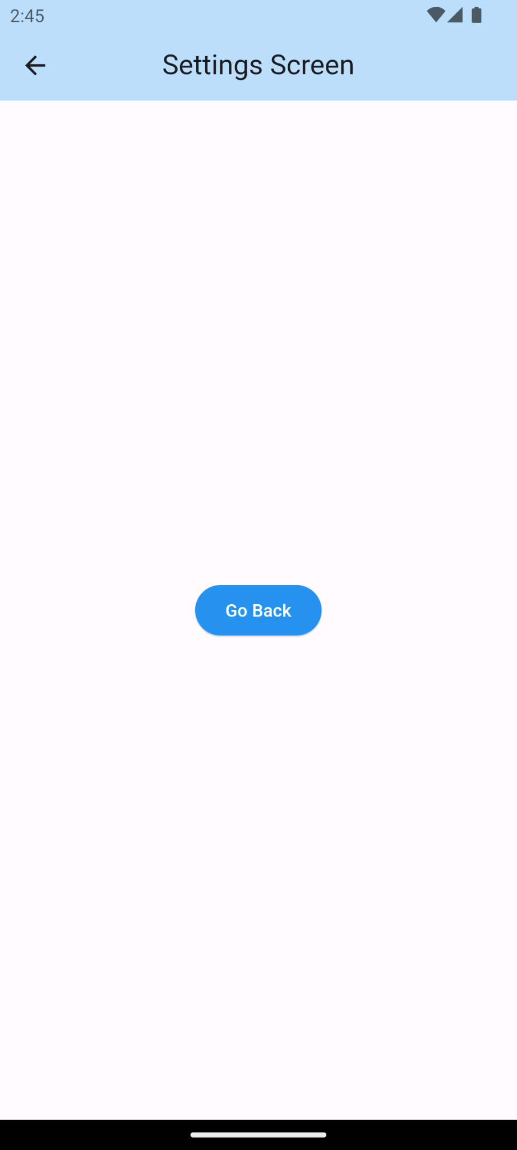

How to submit your workshop
Push your project back to the same git branch using command:
<command name>

Happy Coding!

